**User flow**

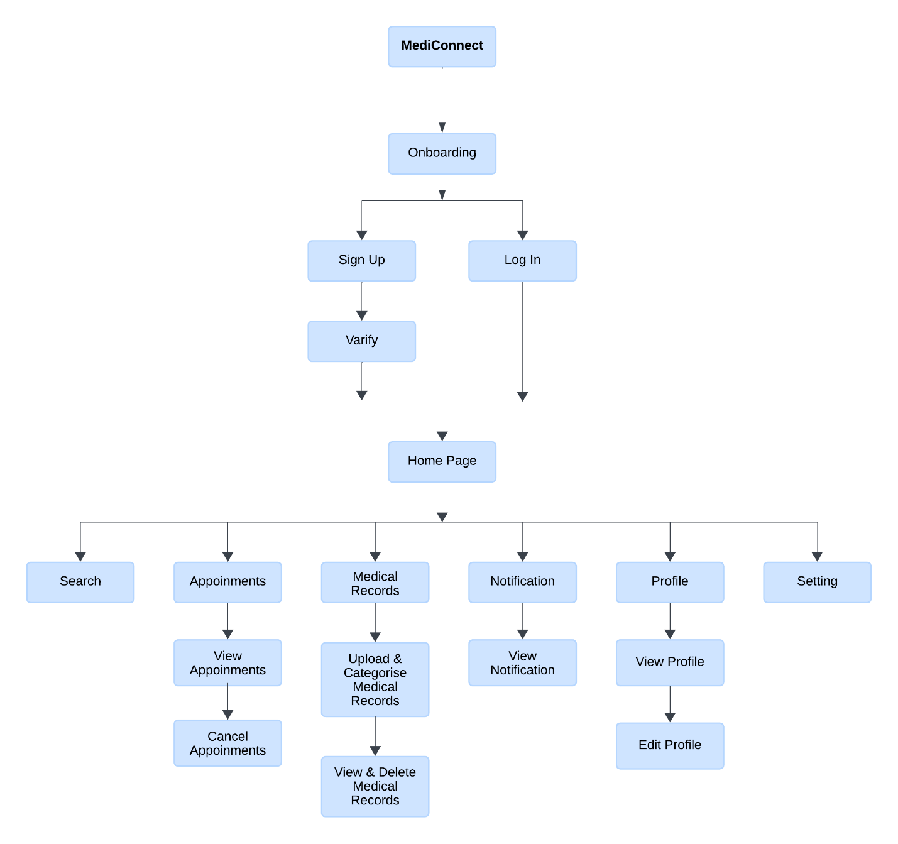

**Onboarding**

* Step 1: Find Your Doctor

-Welcome to DocuBooker! Start by discovering specialists near you.

* Step 2: Book Your Appointment

-Booking made easy! Select your date and time effortlessly.

* Step 3: Manage Your Appointments

-Stay organized! View, reschedule, and cancel appointments easily.

Creating UI designs for a doctor booking app over the course of 30 days is a great challenge. Here's a breakdown of different interfaces you can design for each day:

Week 1: Foundational Screens

Day 1: Splash Screen: Create a welcoming screen with the app logo and loading animation.

Day 2: Login/Registration: Design screens for users to log in or register for a new account.

Day 3: Home Screen: Develop a dashboard showing featured doctors, upcoming appointments, and search options.

Day 4: Doctor Listings: Design a screen listing available doctors with their specialties and ratings.

Day 5: Doctor Profile: Create a detailed profile for a doctor, including bio, reviews, and availability.

Day 6: Appointment Booking: Design a user-friendly interface for scheduling appointments with doctors.

Day 7: Settings: Develop screens for users to manage their profile, notifications, and preferences.

Week 2: Refinement and Navigation

Day 8: Navigation: Design a bottom navigation bar or sidebar for easy access to different app sections.

Day 9: Search Functionality: Enhance the search feature to allow users to find doctors by name, specialty, or location.

Day 10: Filters and Sorting: Develop options to filter and sort search results based on various criteria.

Day 11: Appointment Details: Design screens displaying detailed information about upcoming appointments.

Day 12: Notification Center: Create a screen for users to view and manage appointment reminders and other notifications.

Day 13: Error States: Design interfaces for handling errors, such as invalid login credentials or network issues.

Day 14: Accessibility: Review and improve accessibility features to ensure usability for all users.

Week 3: User Interactions and Feedback

Day 15: Onboarding: Develop a series of screens to guide new users through the app's features and functionality.

Day 16: Feedback Form: Create a form for users to provide feedback on their appointment experience.

Day 17: Ratings and Reviews: Design screens for users to rate and leave reviews for doctors they've visited.

Day 18: Messaging: Develop a messaging interface for users to communicate with doctors or support staff.

Day 19: Profile Editing: Enhance the profile editing screens to allow users to update their information easily.

Day 20: Appointments History: Design screens for users to view past appointments and medical history.

Day 21: Performance Optimization: Review and optimize app performance for smoother user experience.

Week 4: Advanced Features and Testing

Day 22: Telemedicine: Design screens for virtual appointments and video consultations.

Day 23: Integration: Explore integrating additional features like health record access or prescription management.

Day 24: Calendar Integration: Develop features to sync appointments with users' calendars.

Day 25: In-App Payments: Design interfaces for secure in-app payments for appointment fees.

Day 26: Dark Mode: Implement a dark mode option for better usability in low-light environments.

Day 27: Localization: Adapt UI elements for different languages and regions.

Day 28: User Testing: Conduct usability testing with real users and gather feedback for improvements.

Day 29: Iteration and Polishing: Refine designs based on user feedback and testing results.

Day 30: Final Review: Reflect on the 30-day challenge, showcase your designs, and plan next steps.

Remember to prioritize user experience, usability, and accessibility throughout the design process. Happy designing!